Module Design Document
For
ES34E_ePWM Subsystems
ePWM

VERSION: 2.0
DATE: 09-22-2015

Prepared By:
Jayakrishnan T,
Nexteer Automotive,
Saginaw, MI, USA
Location: The official version of this document is stored in the Nexteer Configuration Management System.

Revision History

Sl. No. | Description | Author | Version | Date
1 | Initial Version | Yue Zhao | 1.0 | 06-19-2015
2 | Anomaly fix EA3#3088 - incorrectly computes CmpBPhaseX | Jayakrishnan T | 2.0 | 09-22-2015

Table of Contents
1 Abbrevations And Acronyms 5
2 References 6
3 ePWM and use & High-Level Description 7
4 Design details of software module 8
4.1 Graphical representation of epwm 8
4.2 Data Flow Diagram 8
4.2.1 Module level DFD 8
4.2.2 Sub-Module level DFD 8
4.3 COMPONENT FLOW DIAGRAM 8
5 Variable Data Dictionary 9
5.1 User defined typedef definition/declaration 9
5.2 Variable definition for enumerated types 9
6 Constant Data Dictionary 10
6.1 Program(fixed) Constants 10
6.1.1 Embedded Constants 10
6.1.1.1 Local 10
6.1.1.2 Global 10
6.1.2 Module specific Lookup Tables Constants 10
7 Software Module Implementation 11
7.1 Sub-Module Functions 11
7.2 Initialization Functions 11
7.2.1 Init: <ModuleName>_Init<n> 11
7.2.1.1 Design Rationale 11
7.2.1.2 Module Outputs 11
7.3 PERIODIC FUNCTIONS 11
7.3.1 Per: <ModuleName>_Per<n> 11
7.3.1.1 Design Rationale 11
7.3.1.2 Store Module Inputs to Local copies 11
7.3.1.3 (Processing of function)……… 11
7.3.1.4 Store Local copy of outputs into Module Outputs 11
7.4 Non PERIODIC FUNCTIONS 11
7.4.1 NONPer: <ModuleName>_NONPer<n> 11
7.4.1.1 Design Rationale 11
7.4.1.2 Store Module Inputs to Local copies 11
7.4.1.3 (Processing of function)……… 11
7.4.1.4 Store Local copy of outputs into Module Outputs 11
7.5 Interrupt Functions 12
7.5.1 Isr: <ModuleName>_Isr<n)> 12
7.5.1.1 Design Rationale 12
7.5.1.2 (Processing of the ISR function)….. 12
7.6 Serial Communication Functions 12
7.6.1 SComm: <MODULENAME> 12
7.6.1.1 Design Rationale 12
7.6.1.2 Store Module Inputs to Local copies 12
7.6.1.3 (Processing of function)……… 12
7.6.1.4 Store Local copy of outputs into Module Outputs 12
7.7 Local Function/Macro Definitions 12
7.7.1 Local Function #1 12
7.7.1.1 Description 12
7.8 GLOBAL Function/Macro Definitions 12
7.8.1 GLOBAL Function #1 12
7.8.1.1 Description 13
7.8.2 Global Functions #2 15
7.8.2.1 Design Rationale 15
7.8.2.2 Store Module Inputs to Local copies 15
7.8.2.3 Processing 16
7.8.2.4 Store Local copy of outputs into Module Outputs 16
7.8.3 GLObAL Macros 17
7.8.3.1 Design Rationale 17
7.9 TRANSIENT FUNCTIONS 17
7.9.1 Per: <ModuleName>_Trns<n> 17
7.9.1.1 Design Rationale 17
7.9.1.2 Store Module Inputs to Local copies 17
7.9.1.3 (Processing of function)……… 17
7.9.1.4 Store Local copy of outputs into Module Outputs 17
8 Unit Test Considerations 18
9 Known Limitations With Design 19
10 UNIT TEST CONSIDERATION 20
11 Appendix 21

Abbrevations And Acronyms
Abbreviation | Description
DFD | Design functional diagram
MDD | Module design document
FDD | Functional design document

References
This section lists the title & version of all the documents that are referred for development of this document
Sr. No. | Title | Version
1 | MDD Guidelines | 1.4
2 | Software Naming Conventions | 2.0
3 | FDD: 34E - ePWM Subsystems | 002

ePWM and use & High-Level Description
This module implements functionality with respect to the EPWM module. This module implements the requirements other than the EPWM output direction control, which is implemented in the diverse path as required.

Design details of software module

Graphical representation of epwm
None

Data Flow Diagram
None

Module level DFD
None

Sub-Module level DFD
None

COMPONENT FLOW DIAGRAM
None

Variable Data Dictionary

User defined typedef definition/declaration

Typedef Name | Element Name | User Defined Type | Legal Range  (min) | Legal Range  (max)
None

Variable definition for enumerated types
Enum Name | Element Name | Value
None

Constant Data Dictionary

Program(fixed) Constants

Embedded Constants

Local
Constant Name | Resolution | Units | Value
None

Global

Constant Name
None

Module specific Lookup Tables Constants
Constant Name | Resolution | Value | Software Segment
None

Software Module Implementation

Sub-Module Functions
None

Initialization Functions

Init: <ModuleName>_Init<n>

Design Rationale
None

Module Outputs
None

PERIODIC FUNCTIONS

Per: <ModuleName>_Per<n>

Design Rationale
None

Store Module Inputs to Local copies
None

(Processing of function)………
None

Store Local copy of outputs into Module Outputs
None

Non PERIODIC FUNCTIONS

NONPer: <ModuleName>_NONPer<n>

Design Rationale
None

Store Module Inputs to Local copies
None

(Processing of function)………
None

Store Local copy of outputs into Module Outputs
None

Interrupt Functions
None

Isr: <ModuleName>_Isr<n)>
None

Design Rationale
None

(Processing of the ISR function)…..
None

Serial Communication Functions
None

SComm: <MODULENAME>

Design Rationale
None

Store Module Inputs to Local copies
None

(Processing of function)………
None

Store Local copy of outputs into Module Outputs
None

Local Function/Macro Definitions
None

Local Function #1
None

Description
None

GLOBAL Function/Macro Definitions

GLOBAL Function #1
Function Name | ePWM_Init1 | Type | Min | Max
Arguments Passed | None
Return Value | None

Description

EPWM1
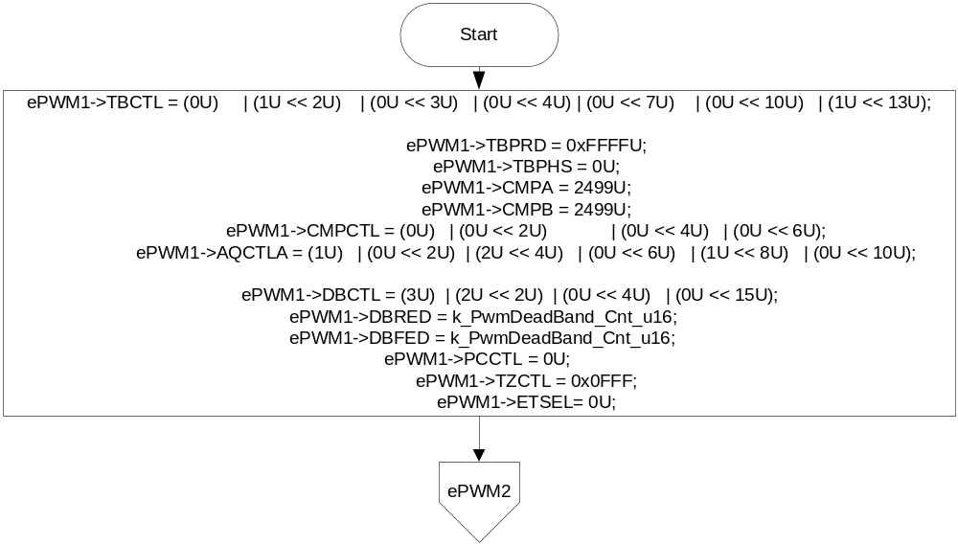
EPWM2
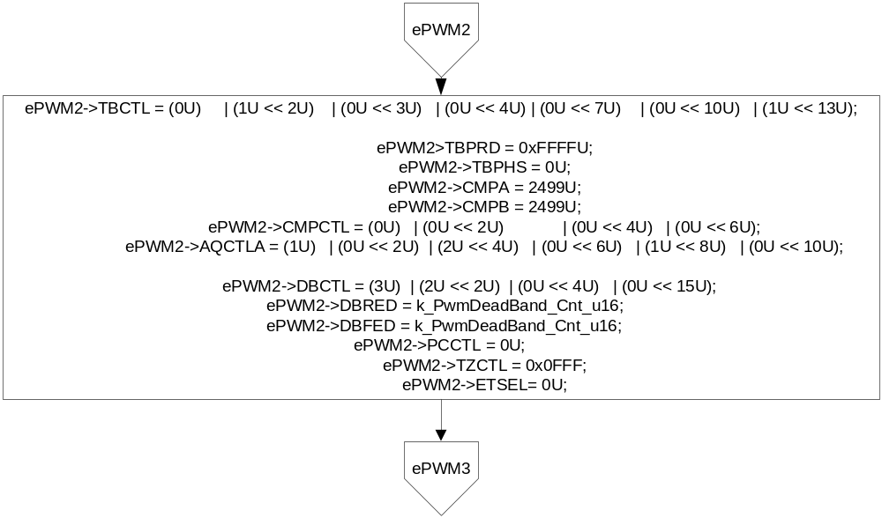

EPWM3
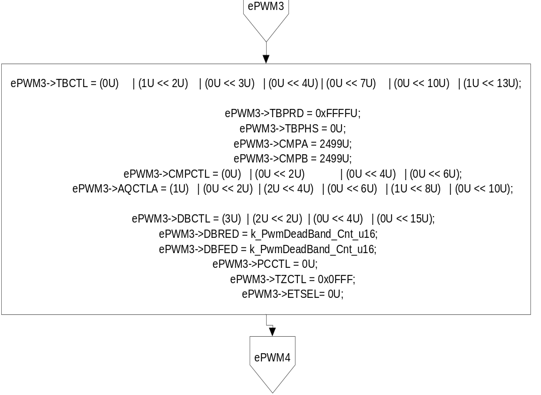
EPWM4
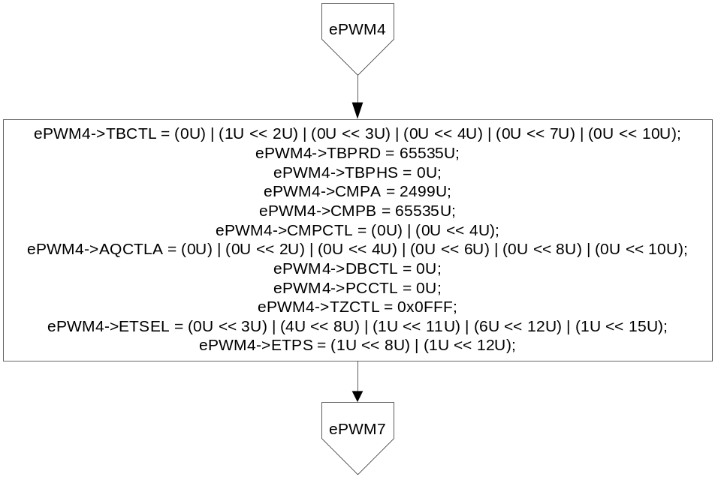

EPWM7
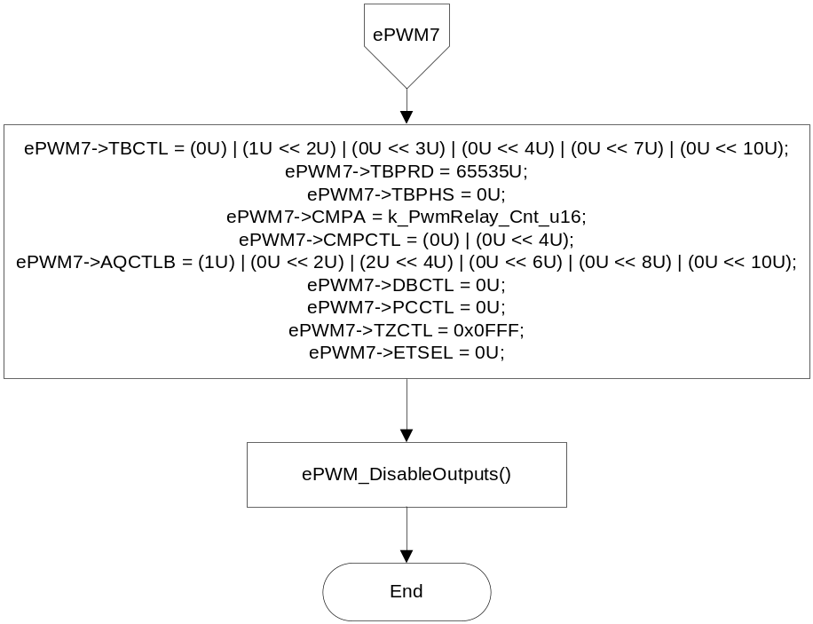

Global Functions #2
Function Name | ePWM_Per1 | Type | Min | Max | UTP Tol.
Arguments Passed | None
Return Value | None

Design Rationale
PWM Period computed by Pwm_Cdd is read and adjusted. Adjusted value is used for computations of the motor control PWM CMPA and CMPB values, and for the ADC SOCA update (ePWM4CMPA).
ADC SOCB update is done in the 2ms loop (see integration manual) then value (ePWM4CMPB) is read by this function and written to the appropriate buffer.
This function is called by the motor control ISR and so data cannot be transferred via the RTE; therefore data is read and written via macros and global variables.
Due to timing constraints of the motor control ISR processing, outputs are not limited to their defined ranges before writing.

Store Module Inputs to Local copies

ePWM_Read_PWMPeriod_u16(&PWMPeriod_Cnt_T_u16)
ePWM_Read_DCPhsAComp_u16(&DCPhsAComp_Cnt_T_u16)
ePWM_Read_DCPhsBComp_u16(&DCPhsBComp_Cnt_T_u16)
ePWM_Read_DCPhsCComp_u16(&DCPhsCComp_Cnt_T_u16)
ePWM_Read_ePWM4CMPB_Cnt_u16(&ePWM4CMPB_Cnt_T_u16)

Processing
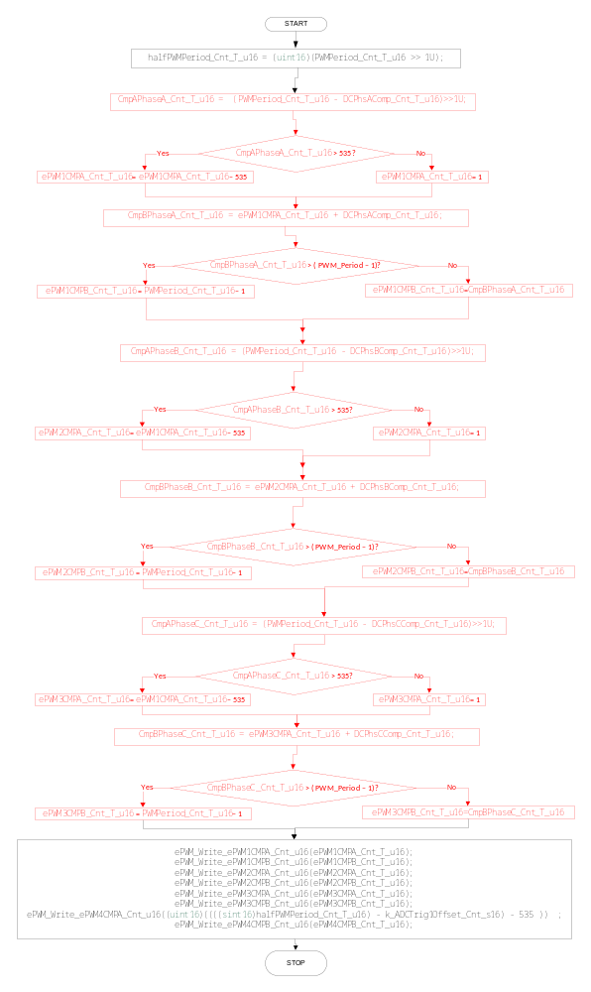

Store Local copy of outputs into Module Outputs

ePWM_Write_ePWM1CMPA_Cnt_u16(ePWM1CMPA_Cnt_T_u16);
ePWM_Write_ePWM1CMPB_Cnt_u16(ePWM1CMPB_Cnt_T_u16);
ePWM_Write_ePWM2CMPA_Cnt_u16(ePWM2CMPA_Cnt_T_u16);
ePWM_Write_ePWM2CMPB_Cnt_u16(ePWM2CMPB_Cnt_T_u16);
ePWM_Write_ePWM3CMPA_Cnt_u16(ePWM3CMPA_Cnt_T_u16);
ePWM_Write_ePWM3CMPB_Cnt_u16(ePWM3CMPB_Cnt_T_u16);
ePWM_Write_ePWM4CMPA_Cnt_u16((uint16)((((sint16)halfPWMPeriod_Cnt_T_u16) - k_ADCTrig1Offset_Cnt_s16) - 535 ));
ePWM_Write_ePWM4CMPB_Cnt_u16(ePWM4CMPB_Cnt_T_u16);

GLObAL Macros
ePWM_Read_PWMPeriod_u16
ePWM_Read_DCPhsAComp_u16
ePWM_Read_DCPhsBComp_u16
ePWM_Read_DCPhsCComp_u16
ePWM_Read_ePWM4CMPB_Cnt_u16
ePWM_Write_ePWM1CMPA_Cnt_u16
ePWM_Write_ePWM1CMPB_Cnt_u16
ePWM_Write_ePWM2CMPA_Cnt_u16
ePWM_Write_ePWM2CMPB_Cnt_u16
ePWM_Write_ePWM3CMPA_Cnt_u16
ePWM_Write_ePWM3CMPB_Cnt_u16
ePWM_Write_ePWM4CMPA_Cnt_u16
ePWM_Write_ePWM4CMPB_Cnt_u16

Design Rationale
These macros are used for updating ePWM duty cycles and periods. They are also used for updating CompA and CompB registers

TRANSIENT FUNCTIONS
None

Per: <ModuleName>_Trns<n>

Design Rationale
None

Store Module Inputs to Local copies
None

(Processing of function)………
None

Store Local copy of outputs into Module Outputs
None

Unit Test Considerations

Known Limitations With Design
None

UNIT TEST CONSIDERATION

None

Appendix
None

